Customer Shopping Behavior Analysis

1. Project Overview

This Project analyzes the behavior of customer shopping using around 3,900 customers that purchases various product along different categories. The objective of this project was to analyze customer purchasing behavior, spending patterns, demographic segmentation, and subscription trends to identify high-value customer groups and revenue growth opportunities for an e-commerce business.

2.Dataset Summary

-Rows 3,900
-Columns 18
-Key features:
-Customer Demographics [Age, Gender, Location, Subscription status]
-Purchase Detail [Item purchase, Category, Purchase amount , Size, Color, Season]
-Shopping behavior [Shipping Type, Discount Applied, Promo Code Used, Previous Purchases, Payment Method, Frequency of Purchases, Review Rating]
-Missing data - 37 values in Review Rating column

3. Data analysis using python

We begin with data processing and cleaning in Python.

Data Loading : imported dataset using pandas
Here below the view some rows and column of data
Used df.info() to check Structure and describe.() to check for summary
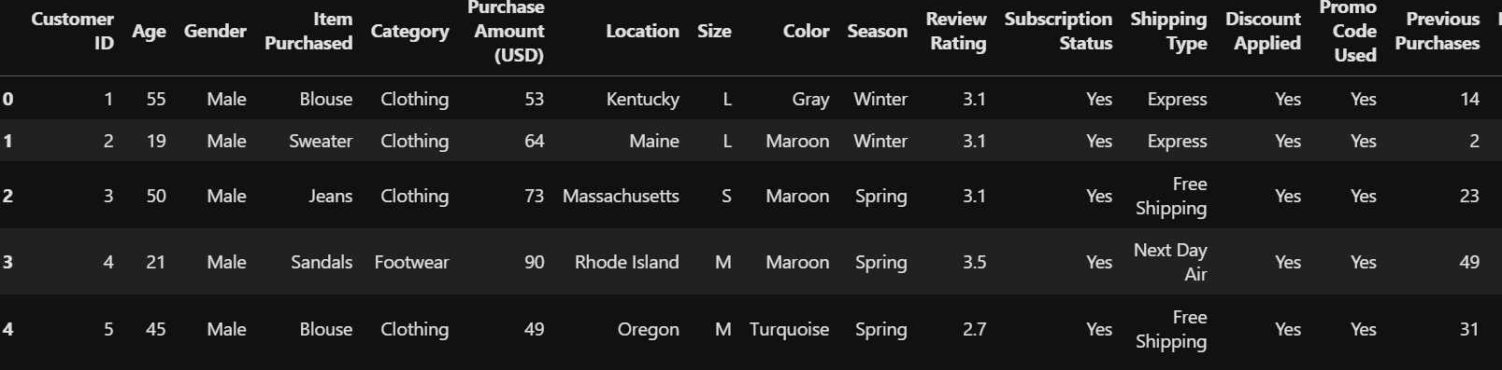

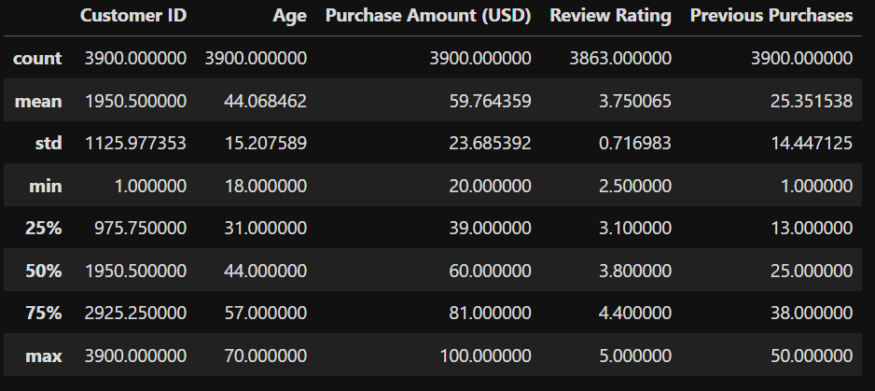

Missing data handling : checked for null value in data and find the 37 null values in Review Rating column. Fixed this value using Median rating of each product category

- Column Standardization : Renamed Columns to lower case for better readability
And documentation

- Feature engineering

Created Columns named age_group for agedwize analysis

Created purchase_frequency_days Column from purchase data

- Data consistency checked

Verified if Discount Applied and Promo Code Used
Were redundant ; dropped Promo Code Used

- Database integration

Connected the python script to Postgres SQL and loaded the nit and cleaned Data
Into Database for further analysis in SQL

4 Data analysis using SQL

We perform various operations on dataset using SQL queries and answer some key business questions

1.What is the total revenue generated by male vs. female customers?

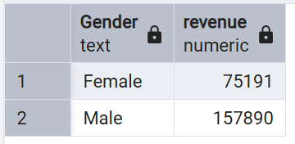

2.Which customers used a discount but still spent more than the average purchase amount?

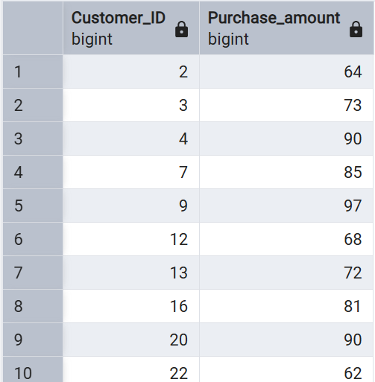

3.Which are the top 5 products with the highest average review rating?
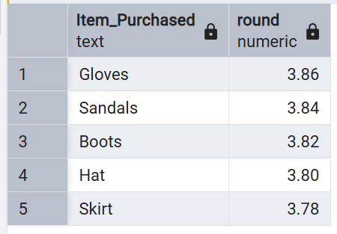

4. Compare the average Purchase Amounts between Standard and Express Shipping.
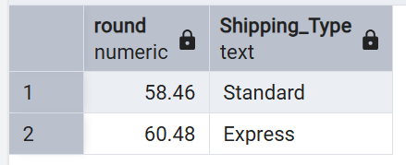

5. Do subscribed customers spend more? Compare average spend and total revenue between subscribers and non-subscribers.

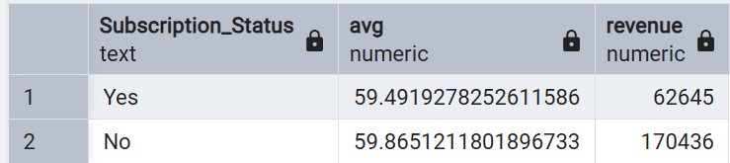

6.Which 5 products have the highest percentage of purchases with discounts applied?
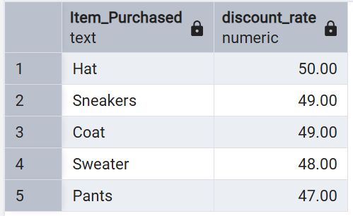

7. Segment customers into New, Returning, and Loyal based on their total number of previous purchases, and show the count of each segment.
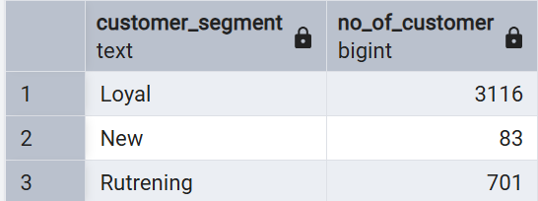

8. What are the top 3 most purchased products within each category?
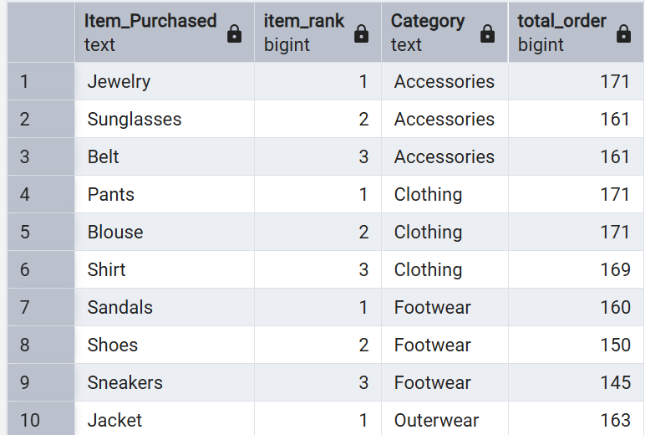

9.Are customers who are repeat buyers (more than 5 previous purchases) also likely to subscribe?

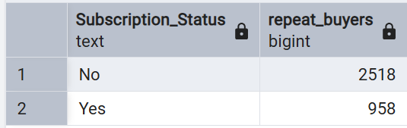

10.What is the revenue contribution of each age group?

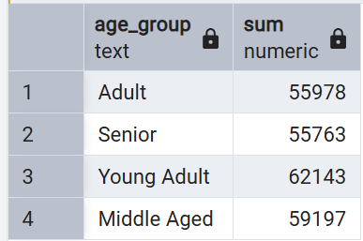

5 Dashboard using Power bi

- Use of Visuals to visualized data set and create interactive dashboard
Where we can easily see our expected information

Below the Dashboard of Customer behavior Analysis
